# Python Radio 40: **Unleashing the CC1101**

## **Advanced Packet Radio**

[](https://medium.com/@simon.field_37276?source=post_page---byline--d918ab21416b---------------------------------------)

[Simon Quellen Field](https://medium.com/@simon.field_37276?source=post_page---byline--d918ab21416b---------------------------------------)

Follow

20 min read

·

May 28, 2025

Listen

Share

More

Press enter or click to view image in full size

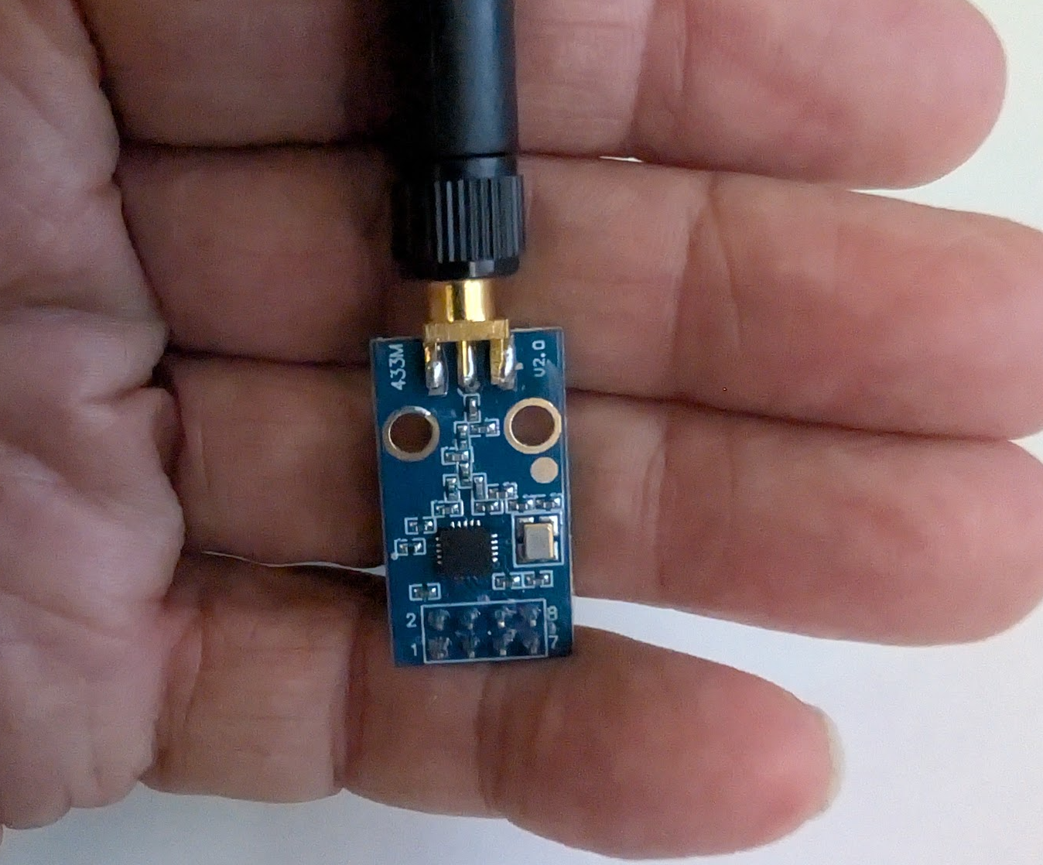

All photos by the Author

We used the CC1101 transceiver earlier as a CW transmitter (Morse Code).

But the radio can do so much more.

It is a full transceiver:

* It can transmit and receive at data rates from 600 baud up to 600,000 baud.
* It has programmable filters to match the signal-to-noise ratio to the baud rate.
* It has automated packet handling, with preambles, sync words, checksums and forward error correction, modulation and demodulation, bit synchronization, byte synchronization, whitening and de-whitening, interleaving, and decoding. All without burdening the computer.
* It supports amplitude modulation, frequency modulation, and phase modulation, and on-off keying. It can also handle Manchester coding and decoding.
* In frequency shift keying, it can support 2-FSK, 4-FSK, and it has a Gaussian filter (GFSK) to allow higher data rates in narrower bandwidths.
* It can perform six different tests to determine link quality.

So let’s explore some of the more powerful aspects of the radio.

### Connecting to the ESP32

Since we want both a transmitter and a receiver, let’s use two different ESP32 boards — the ESP32-S3 and the ESP32-C3 Super Mini.

The radio has 8 pins. We will use seven of them.

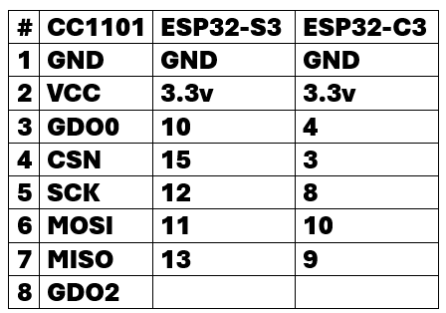

Pin Connections

Our ESP32-C3 looks like this on the breadboard:

Press enter or click to view image in full size

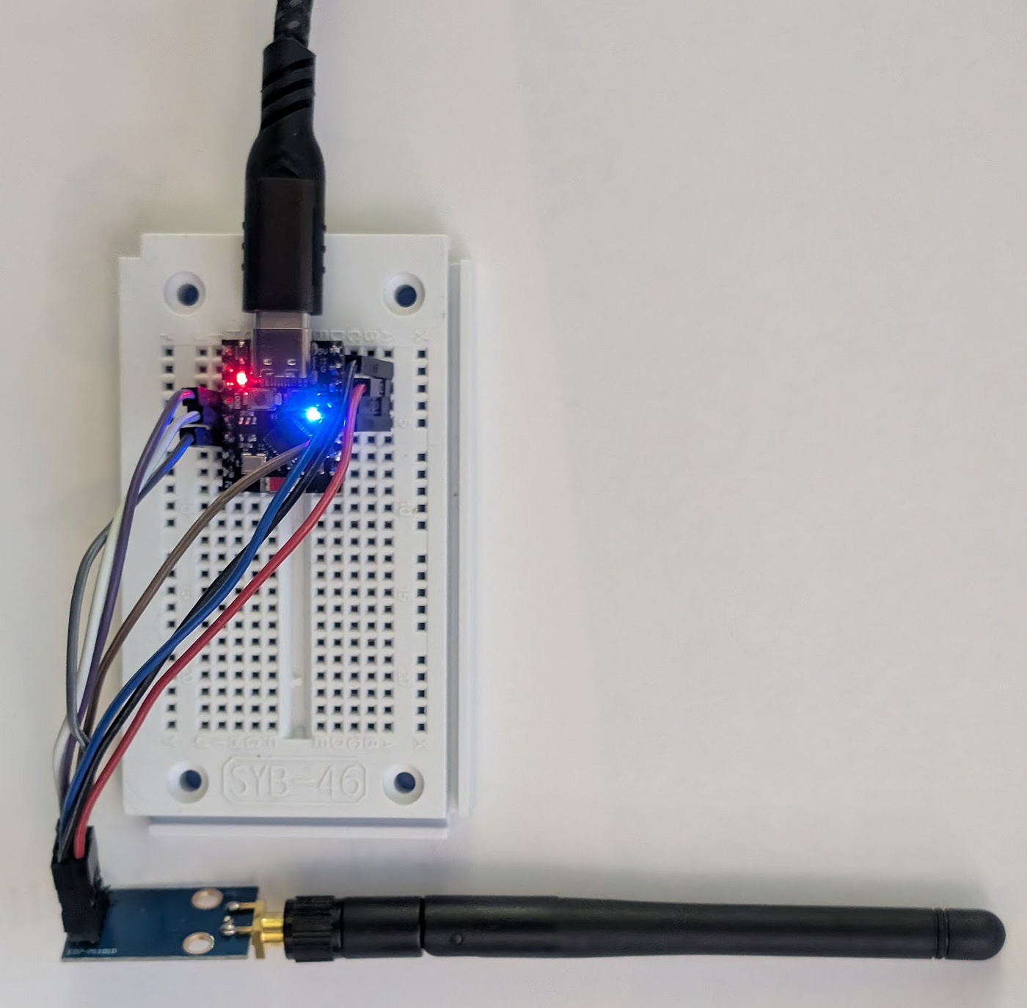

The ESP32-S3 is a larger board, and needed two breadboards:

Press enter or click to view image in full size

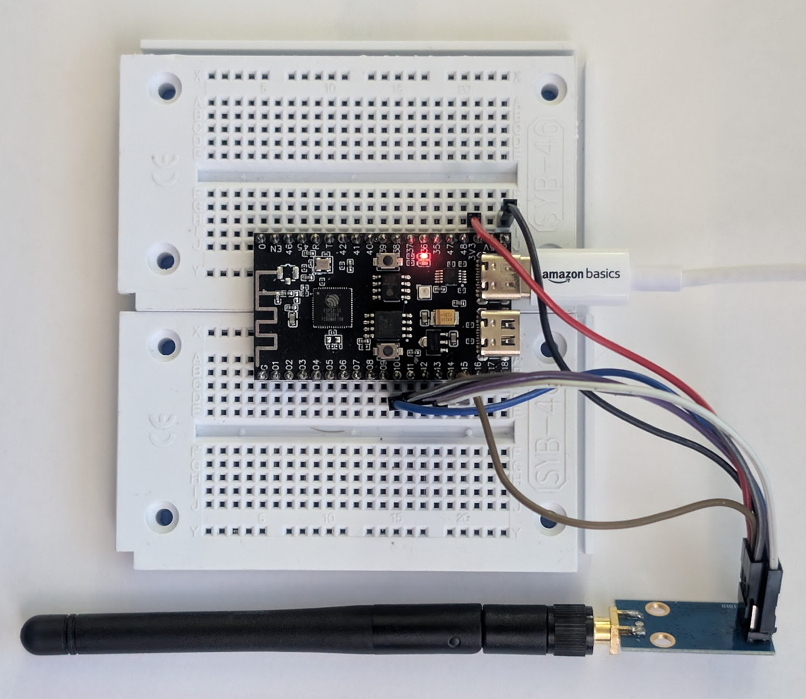

### Frequencies

The radio can transmit and receive on several license-free bands:

* 300 to 348 Megahertz
* 387 to 464 Megahertz
* 779 to 928 Megahertz

I chose the middle band, specifically 433.92 MHz, for a few reasons. First, it lies in the 70-centimeter amateur radio band, which extends from 420 MHz to 450 MHz in the U.S. This means I can choose to amplify the output if I choose (and if I obey the amateur radio rules). It also means my 70-centimeter antennas will work with it. But also, longer wavelengths come with longer ranges, and the 800 and 900 MHz frequencies don’t have the range of 433 MHz.

I get about a kilometer with the tiny antennas that come with the radio, even though the radio only emits 12 dBm (15.85 milliwatts).

### The Software

To show the features and power of the radio, we will send and receive packets with preamble words, sync words, forward error correction, and checksums, all handled in the radio without having to code them up in the ESP32.

Here is the code:

from machine import Pin, SPI  
from time import sleep, sleep_ms, sleep_us, ticks_diff, ticks_ms  
from sys import print_exception  
  
from whoami import WhoAmI  
w = WhoAmI()  
  
# Configuration Registers  
IOCFG2 = 0x00 # GDO2 Output Pin Configuration  
IOCFG1 = 0x01 # GDO1 Output Pin Configuration  
IOCFG0 = 0x02 # GDO0 Output Pin Configuration  
FIFOTHR = 0x03 # RX FIFO and TX FIFO Thresholds  
SYNC1 = 0x04 # Sync Word, High Byte  
SYNC0 = 0x05 # Sync Word, Low Byte  
PKTLEN = 0x06 # Packet Length  
PKTCTRL1 = 0x07 # Packet Automation Control  
PKTCTRL0 = 0x08 # Packet Automation Control  
ADDR = 0x09 # Device Address  
CHANNR = 0x0A # Channel Number  
FSCTRL1 = 0x0B # Frequency Synthesizer Control  
FSCTRL0 = 0x0C # Frequency Synthesizer Control  
FREQ2 = 0x0D # Frequency Control Word, High Byte  
FREQ1 = 0x0E # Frequency Control Word, Middle Byte  
FREQ0 = 0x0F # Frequency Control Word, Low Byte  
MDMCFG4 = 0x10 # Modem Configuration  
MDMCFG3 = 0x11 # Modem Configuration  
MDMCFG2 = 0x12 # Modem Configuration  
MDMCFG1 = 0x13 # Modem Configuration  
MDMCFG0 = 0x14 # Modem Configuration  
DEVIATN = 0x15 # Modem Deviation Setting  
MCSM2 = 0x16 # Main Radio Control State Machine Configuration  
MCSM1 = 0x17 # Main Radio Control State Machine Configuration  
MCSM0 = 0x18 # Main Radio Control State Machine Configuration  
FOCCFG = 0x19 # Frequency Offset Compensation Configuration  
BSCFG = 0x1A # Bit Synchronization Configuration  
AGCCTRL2 = 0x1B # AGC Control  
AGCCTRL1 = 0x1C # AGC Control  
AGCCTRL0 = 0x1D # AGC Control  
WOREVT1 = 0x1E # High Byte Event0 Timeout  
WOREVT0 = 0x1F # Low Byte Event0 Timeout  
WORCTRL = 0x20 # Wake On Radio Control  
FREND1 = 0x21 # Front End RX Configuration  
FREND0 = 0x22 # Front End TX Configuration  
FSCAL3 = 0x23 # Frequency Synthesizer Calibration  
FSCAL2 = 0x24 # Frequency Synthesizer Calibration  
FSCAL1 = 0x25 # Frequency Synthesizer Calibration  
FSCAL0 = 0x26 # Frequency Synthesizer Calibration  
RCCTRL1 = 0x27 # RC Oscillator Configuration  
RCCTRL0 = 0x28 # RC Oscillator Configuration  
FSTEST = 0x29 # Frequency Synthesizer Calibration Control  
PTEST = 0x2A # Production Test  
AGCTEST = 0x2B # AGC Test  
TEST2 = 0x2C # Various Test Settings  
TEST1 = 0x2D # Various Test Settings  
TEST0 = 0x2E # Various Test Settings  
  
reg_names = [  
 "IOCFG2",  
 "IOCFG1",  
 "IOCFG0",  
 "FIFOTHR",  
 "SYNC1",  
 "SYNC0",  
 "PKTLEN",  
 "PKTCTRL1",  
 "PKTCTRL0",  
 "ADDR",  
 "CHANNR",  
 "FSCTRL1",  
 "FSCTRL0",  
 "FREQ2",  
 "FREQ1",  
 "FREQ0",  
 "MDMCFG4",  
 "MDMCFG3",  
 "MDMCFG2",  
 "MDMCFG1",  
 "MDMCFG0",  
 "DEVIATN",  
 "MCSM2",  
 "MCSM1",  
 "MCSM0",  
 "FOCCFG",  
 "BSCFG",  
 "AGCCTRL2",  
 "AGCCTRL1",  
 "AGCCTRL0",  
 "WOREVT1",  
 "WOREVT0",  
 "WORCTRL",  
 "FREND1",  
 "FREND0",  
 "FSCAL3",  
 "FSCAL2",  
 "FSCAL1",  
 "FSCAL0",  
 "RCCTRL1",  
 "RCCTRL0",  
 "FSTEST",  
 "PTEST",  
 "AGCTEST",  
 "TEST2",  
 "TEST1",  
 "TEST0",  
]  
  
# Status Registers (accessed with Read Single/Burst + 0x80/0xC0, or specific status byte commands)  
PARTNUM = 0xF0 # Chip ID (Should be 0x00 for CC1101)  
VERSION = 0xF1 # Chip ID (Should be 0x04 for CC1101)  
FREQEST = 0xF2 # Frequency Offset Estimate from Demodulator  
LQI = 0xF3 # Demodulator Estimate for Link Quality  
RSSI = 0xF4 # Received Signal Strength Indication  
MARCSTATE = 0xF5 # Main Radio Control State Machine State  
WORTIME1 = 0xF6 # High Byte of WOR Time  
WORTIME0 = 0xF7 # Low Byte of WOR Time  
PKTSTATUS = 0xF8 # Current GDOx Status and Packet Status  
VCO_VC_DAC = 0xF9# Current Setting from PLL Calibration Module  
TXBYTES = 0xFA # Underflow and Number of Bytes  
RXBYTES = 0xFB # Overflow and Number of Bytes  
RCCTRL1_STATUS = 0xFC # Last RC Oscillator Calibration Result  
RCCTRL0_STATUS = 0xFD # Last RC Oscillator Calibration Result  
  
# Strobe Commands  
SRES = 0x30 # Reset chip.  
SFSTXON = 0x31 # Enable and calibrate frequency synthesizer (if MCSM0.FS_AUTOCAL=1).  
SXOFF = 0x32 # Turn off crystal oscillator.  
SCAL = 0x33 # Calibrate frequency synthesizer and turn it off.  
SRX = 0x34 # Enable RX.  
STX = 0x35 # Enable TX.  
SIDLE = 0x36 # Exit RX/TX, turn off frequency synthesizer.  
SWOR = 0x38 # Start automatic RX polling sequence (Wake-on-Radio)  
SPWD = 0x39 # Enter power down mode when CSn goes high.  
SFRX = 0x3A # Flush the RX FIFO buffer.  
SFTX = 0x3B # Flush the TX FIFO buffer.  
SWORRST = 0x3C # Reset real time clock.  
SNOP = 0x3D # No operation.  
  
# PATABLE and FIFO Addresses  
PATABLE_ADDR = 0x3E # Address for PATABLE  
TXFIFO_ADDR = 0x3F # TX FIFO address  
RXFIFO_ADDR = 0x3F # RX FIFO address  
  
# SPI Header Bits  
WRITE_SINGLE_BYTE = 0x00  
WRITE_BURST = 0x40  
READ_SINGLE_BYTE = 0x80  
READ_BURST = 0xC0  
  
# Note: For status registers (0x30-0x3D, which become 0xF0-0xFD with burst bit),  
# the datasheet often shows them accessed with the burst bit set.  
# e.g., MARCSTATE (0x35) is read with 0x35 | 0xC0 = 0xF5.  
  
# --- Constants ---  
FXOSC = 26000000 # Crystal oscillator frequency in Hz (26MHz)  
MAX_PACKET_LEN = 60 # Max payload length. FIFO is 64 bytes. (1 length byte + payload + 2 status bytes + FEC padding)  
  
class CC1101:  
 def __init__(self, spi, cs_pin_id, gdo0_pin_id=None):  
 self.rssi_dbm = -99  
 self.spi = spi  
 self.cs = Pin(cs_pin_id, Pin.OUT)  
 self.cs.on() # Active low, so set high initially  
 self.use_variable_length_packets = False  
  
 self.gdo0 = None  
 if gdo0_pin_id is not None:  
 # Configure GDO0 as input with pull-down  
 # (GDO0 is typically active high from CC1101)  
 self.gdo0 = Pin(gdo0_pin_id, Pin.IN, Pin.PULL_DOWN)  
 print(f"GDO0 configured on GPIO {gdo0_pin_id}")  
  
 self.reset()  
  
 print("Attempting to go IDLE immediately after reset...")  
 self.idle()  
  
 print("--- Basic Register Read Test ---")  
 try:  
 marc_state = self._read_status_reg(MARCSTATE) & 0x1F  
 partnum = self._read_status_reg(PARTNUM) # PARTNUM is 0x30, so 0x30|0xC0 = 0xF0  
 version = self._read_status_reg(VERSION) # VERSION is 0x31, so 0x31|0xC0 = 0xF1  
 # print(f"MARCSTATE after initial idle attempt: 0x{marc_state:02X}")  
 # print(f"PARTNUM: 0x{partnum:02X} (Expected: 0x00 for CC1101)")  
 # print(f"VERSION: 0x{version:02X} (Expected: >= 0x04, e.g., 0x14 for rev E)")  
  
 # Test basic register write/read  
 self._write_reg(CHANNR, 0xAA)  
 channr_read = self._read_reg(CHANNR)  
 # print(f"Wrote 0xAA to CHANNR, Read: 0x{channr_read:02X}")  
 if channr_read != 0xAA:  
 print("ERROR: Basic register write/read test FAILED!")  
 else:  
 print("Basic register write/read test PASSED.")  
  
 except Exception as e:  
 print(f"Error during basic register read test: {e}")  
 print_exception(e)  
  
 # self.dump_regs()  
 # self.snop_test()  
  
 self.current_data_rate_kbps = w.baud()  
 self.has_FEC = w.fec()  
  
 self.configure_gfsk(self.current_data_rate_kbps)  
  
 def snop_test(self):  
 SNOP = 0x3D  
 self.cs.on()  
  
 print("Performing SNOP test...")  
 sleep_ms(10)  
  
 self.cs.off()  
 sleep_us(10)  
  
 tx_buf = bytearray([SNOP])  
 rx_buf = bytearray(1)  
 self.spi.write_readinto(tx_buf, rx_buf)  
 status_byte = rx_buf[0]  
  
 sleep_us(10)  
 self.cs.on()  
  
 print(f"Status byte after SNOP: 0x{status_byte:02X}")  
 chip_rdyn = status_byte & 0x80  
 state = (status_byte >> 4) & 7  
 fifo_bytes = status_byte & 15  
 states = ["IDLE", "RX", "TX", "FSTXON", "CALIBRATE", "SETTLING", "RXFIFO_OVERFLOW", "TXFIFO_OVERFLOW"]  
 print(f"CHIP_RDYn: {chip_rdyn}")  
 print(f"STATE : {state} {states[state]}")  
 print(f"FIFO : {fifo_bytes}")  
  
 def dump_regs(self):  
 for i in range(0x2F):  
 reg = self._read_reg(i)  
 print(f"{i:02X} {reg_names[i]:8s}: {reg:02X}")  
  
 def _strobe(self, cmd):  
 self.cs.off()  
 self.spi.write(bytearray([cmd]))  
 self.cs.on()  
 sleep_us(50)  
  
 def _write_reg(self, addr, value):  
 self.cs.off()  
 self.spi.write(bytearray([addr | WRITE_SINGLE_BYTE, value]))  
 self.cs.on()  
 sleep_us(50)  
  
 def _read_reg(self, addr):  
 self.cs.off()  
 wbuf = bytearray([addr | READ_SINGLE_BYTE, 0x00])  
 rbuf = bytearray([0, 0])  
 self.spi.write_readinto(wbuf, rbuf)  
 val = rbuf[1]  
 self.cs.on()  
 sleep_us(50)  
 return val  
  
 def _read_status_reg(self, status_reg_addr_with_burst_bit):  
 self.cs.off()  
 wbuf = bytearray([status_reg_addr_with_burst_bit, 0x00])  
 rbuf = bytearray([0, 0])  
 self.spi.write_readinto(wbuf, rbuf)  
 val = rbuf[1]  
 self.cs.on()  
 sleep_us(50)  
 return val  
  
 def _write_burst_reg(self, addr, data):  
 self.cs.off()  
 self.spi.write(bytearray([addr | WRITE_BURST]))  
 self.spi.write(bytearray(data))  
 self.cs.on()  
 sleep_us(50)  
  
 def _read_burst_reg(self, addr, length):  
 self.cs.off()  
 wbuf = bytearray([addr | READ_BURST] + [0x00]*length)  
 rbuf = bytearray([addr | READ_BURST] + [0x00]*length)  
 self.spi.write_readinto(wbuf, rbuf)  
 data = rbuf[1:]  
 self.cs.on()  
 sleep_us(50)  
 return data  
   
 def reset(self):  
 self.cs.off()  
 sleep_us(10)  
 self.cs.on()  
 sleep_us(45)  
 self._strobe(SRES)  
 sleep_ms(2)  
  
 def configure_gfsk(self, data_rate_kbps):  
 print(f"Configuring CC1101 for GFSK at approximately {data_rate_kbps} kBaud...")  
  
 current_mdmcfg4 = 0x2D   
 current_mdmcfg3 = 0x3B  
 current_deviatn = 0x62  
 current_fsctrl1 = 0x0C  
 current_agcctrl2 = 0xC7  
 current_agcctrl1 = 0x00  
 current_agcctrl0 = 0xB0  
  
 if data_rate_kbps == 250:  
 print("Using 250 kBaud settings...")  
 # MDMCFG4, MDMCFG3, DEVIATN already set to 250k defaults above  
 # FSCTRL1, AGCCTRLx also already set to 250k defaults above  
  
 elif data_rate_kbps == 38.4:  
 print("Using ~38.4 kBaud settings...")  
 current_mdmcfg4 = 0xA8 # DRATE_E=8, CHANBW_E=2, CHANBW_M=2 => RX BW ~135 kHz  
 current_mdmcfg3 = 0x93 # DRATE_M=147  
 current_deviatn = 0x35 # Deviation ~19kHz  
   
 current_fsctrl1 = 0x06 # IF ~152 kHz for 38.4k  
 current_agcctrl2 = 0x03  
 current_agcctrl1 = 0x40  
 current_agcctrl0 = 0x92   
 else:  
 print(f"ERROR: No pre-defined settings for {data_rate_kbps} kBaud. Using 250k defaults.")  
  
 self._write_reg(MDMCFG4, current_mdmcfg4)  
 self._write_reg(MDMCFG3, current_mdmcfg3)  
 self._write_reg(DEVIATN, current_deviatn)  
   
 self._write_reg(FSCTRL1, current_fsctrl1)  
 self._write_reg(FSCTRL0, 0x00)  
  
 self._write_reg(MDMCFG2, 0x13) # MOD_FORMAT=GFSK, SYNC_MODE=30/32  
  
 if self.has_FEC:  
 print("We are using Forward Error Correction")  
 self._write_reg(MDMCFG1, 0xA2) # FEC_EN, NUM_PREAMBLE=4 bytes  
 else:  
 self._write_reg(MDMCFG1, 0x22) # FEC_DIS, NUM_PREAMBLE=4 bytes  
  
 self._write_reg(MDMCFG0, 0xF8) # CHANSPC_M  
  
 self._write_reg(MCSM2, 0x07)  
 self._write_reg(MCSM1, 0x30) # RXOFF_MODE=IDLE, TXOFF_MODE=IDLE  
 self._write_reg(MCSM0, 0x18) # FS_AUTOCAL from IDLE  
   
 self._write_reg(FOCCFG, 0x1D)  
 self._write_reg(BSCFG, 0x1C)  
   
 self._write_reg(AGCCTRL2, current_agcctrl2)  
 self._write_reg(AGCCTRL1, current_agcctrl1)  
 self._write_reg(AGCCTRL0, current_agcctrl0)  
  
 self._write_reg(FREND1, 0xB6)  
 self._write_reg(FREND0, 0x10)  
   
 self._write_reg(FSCAL3, 0xEA)  
 self._write_reg(FSCAL2, 0x2A)  
 self._write_reg(FSCAL1, 0x00)  
 self._write_reg(FSCAL0, 0x1F)  
  
 self._write_reg(PKTCTRL0, 0x04) # CRC_EN=1, Fixed Length, WHITE_DATA=0  
 self._write_reg(PKTCTRL1, 0x04) # APPEND_STATUS=1  
  
 self._write_reg(PKTLEN, MAX_PACKET_LEN)  
 self._write_reg(IOCFG0, 0x06)  
  
 self.set_tx_power(0xC0)  
 self.set_address(0x00) # Not used if PKTCTRL1.ADR_CHK = 0  
 self.set_channel(0)  
 self.set_sync_word(0xD3, 0x91)  
   
 self.idle()  
  
 print(f"CC1101 GFSK Configuration for ~{data_rate_kbps} kBaud Applied.")  
 return True  
  
  
 def set_frequency_mhz(self, freq_mhz):  
 freq_hz = int(freq_mhz * 1_000_000)  
 # Formula: FREQ_REG = (freq_hz / FXOSC) * 2^16  
 freq_reg_val = int((freq_hz * (1 << 16)) / FXOSC)  
   
 f2 = (freq_reg_val >> 16) & 0xFF  
 f1 = (freq_reg_val >> 8) & 0xFF  
 f0 = freq_reg_val & 0xFF  
   
 self._write_reg(FREQ2, f2)  
 self._write_reg(FREQ1, f1)  
 self._write_reg(FREQ0, f0)  
 print(f"Set Frequency: {freq_hz/1e6:.3f} MHz (Registers: F2:0x{f2:02X}, F1:0x{f1:02X}, F0:0x{f0:02X})")  
 # It's good practice to recalibrate after frequency change if going to TX/RX  
 # self._strobe(SCAL)  
 # while (self._read_status_reg(MARCSTATE) & 0x1F) != 0x01: sleep_us(100) # Wait for CAL to finish (IDLE state)  
  
  
 def set_tx_power(self, power_val_pa_table_entry=0xC0):  
 # For GFSK/FSK/MSK, only the first byte of PATABLE is used.  
 # Common values: 0x00 (-30dBm), 0x12 (-20dBm), ..., 0xC0 (+10dBm)  
 self._write_reg(PATABLE_ADDR, power_val_pa_table_entry)  
  
 def set_address(self, addr_byte):  
 self._write_reg(ADDR, addr_byte)  
  
 def set_channel(self, channr_byte):  
 self._write_reg(CHANNR, channr_byte)  
   
 def set_sync_word(self, sync1_byte, sync0_byte):  
 self._write_reg(SYNC1, sync1_byte)  
 self._write_reg(SYNC0, sync0_byte)  
  
 def idle(self):  
 self._strobe(SIDLE)  
 sleep_ms(1)  
 # Wait until the chip is in IDLE state (MARCSTATE == 0x01)  
 for x in range(150):  
 current_marc_state = self._read_status_reg(MARCSTATE) & 0x1F  
 final_marc_state = current_marc_state  
 if current_marc_state == 0x01:  
 return  
 sleep_us(200)  
 print("Warning: CC1101 did not enter IDLE state after SIDLE strobe.")  
 print(f"Warning: CC1101 did not confirm IDLE state after SIDLE strobe. Last MARCSTATE read: 0x{final_marc_state:02X}")  
  
  
 def enter_rx(self):  
 self.idle()  
 self._strobe(SFRX)  
 self._strobe(SRX)  
  
 def pad(self, data, length):  
 l = len(data)  
 if l >= length:  
 return data[:length]  
 else:  
 padding_needed = length - l  
 data.extend(b'\x00' * padding_needed)  
 return data  
  
 def send_packet(self, data, tx_timeout_ms=1000):  
  
 data = self.pad(data, MAX_PACKET_LEN)  
  
 fixed_payload_length = len(data)  
  
 if not (0 < fixed_payload_length <= MAX_PACKET_LEN):  
 print(f"Error: Packet payload length {fixed_payload_length} invalid (must be 1 to {MAX_PACKET_LEN}).")  
 return False  
  
 self.idle()  
 self._strobe(SFTX)  
  
 tx_bytes_status = self._read_status_reg(TXBYTES)  
  
  
 if self.use_variable_length_packets:  
 print(f"TX: Writing length byte: {fixed_payload_length}")  
 # First byte to TXFIFO is the length of the payload  
 self._write_reg(TXFIFO_ADDR, fixed_payload_length)  
 # Then write the payload data  
 self._write_burst_reg(TXFIFO_ADDR, data)  
 else:  
 self._write_burst_reg(TXFIFO_ADDR, data)  
   
 # Verify bytes in TX FIFO (optional debug)  
 tx_bytes_status = self._read_status_reg(TXBYTES)  
 # print(f"tx_bytes_status is {tx_bytes_status}")  
  
 # print(f"MARCSTATE before STX: 0x{self._read_status_reg(MARCSTATE) & 0x1F:02X}")  
 self._strobe(STX) # Start transmission  
 sleep_us(100) # Give strobe time to process  
 # print(f"MARCSTATE after STX: 0x{self._read_status_reg(MARCSTATE) & 0x1F:02X}")  
  
 start_time = ticks_ms()  
 tx_completed_successfully = False  
  
 if self.gdo0:  
 # Wait for GDO0 to go high (sync word sent) then low (packet sent, chip returns to IDLE or other state based on MCSM1)  
 # With IOCFG0 = 0x06, GDO0 goes high when sync is sent, and low when packet is fully sent and radio leaves TX.  
 gdo0_high_seen = False  
 gdo0_val = self.gdo0.value()  
 while ticks_diff(ticks_ms(), start_time) < tx_timeout_ms:  
 gdo0_val = self.gdo0.value()  
 if not gdo0_high_seen and gdo0_val == 1:  
 gdo0_high_seen = True # Sync word sent, payload transmission in progress  
 if gdo0_high_seen and gdo0_val == 0:  
 # GDO0 went low after being high, check MARCSTATE to confirm IDLE  
 sleep_us(100)  
 if (self._read_status_reg(MARCSTATE) & 0x1F) == 0x01: # IDLE state  
 tx_completed_successfully = True  
 break  
 # If not IDLE, it might be an error state or unexpected transition  
 sleep_us(100) # Poll GDO0  
  
 self.idle() # Ensure radio is IDLE after TX attempt (this calls SIDLE)  
  
 if not tx_completed_successfully:  
 final_marc_state_on_timeout = self._read_status_reg(MARCSTATE) & 0x1F  
 tx_bytes_final = self._read_status_reg(TXBYTES) # Read the full TXBYTES register  
 print(f"TX Failure: MARCSTATE=0x{final_marc_state_on_timeout:02X}, TXBYTES_REG=0x{tx_bytes_final:02X} (UF: {tx_bytes_final>>7}, Num: {tx_bytes_final&0x7F})")  
 gdo0_val = self.gdo0.value()  
 self._strobe(SFTX)  
 self.dump_regs()  
 print()  
 return False  
  
 self.idle()  
   
 if not tx_completed_successfully:  
 self._strobe(SFTX)  
 return False  
   
 # print("TX: Packet sent successfully.")  
 return True  
  
 def receive_packet(self, rx_timeout_ms=1000):  
 self.enter_rx()  
  
 start_time = ticks_ms()  
 packet_detected_by_gdo0 = False  
 baud = int(w.baud() * 1000)  
  
 if self.gdo0:  
 # Wait for GDO0 to go high (sync word received)  
 while ticks_diff(ticks_ms(), start_time) < rx_timeout_ms:  
 if self.gdo0.value() == 1:  
 packet_detected_by_gdo0 = True  
 break # Sync word detected, proceed to wait for end of packet  
 sleep_us(100)  
  
 if packet_detected_by_gdo0:  
 # print("Sync word detected")  
 # Now wait for GDO0 to go low (end of packet transmission)  
 eop_start_time = ticks_ms()  
 # Max EOP wait: roughly time for max packet at current baud rate + buffer  
 max_eop_wait_ms = (5 * MAX_PACKET_LEN * 8 * 1000 // baud) + 50  
   
 while self.gdo0.value() == 1 and ticks_diff(ticks_ms(), eop_start_time) < max_eop_wait_ms:  
 sleep_us(100)  
   
 if self.gdo0.value() == 0:  
 # print("End of packet detected")  
 pass  
 else: # GDO0 stuck high or EOP timeout  
 current_marc_state_eop_timeout = self._read_status_reg(MARCSTATE) & 0x1F  
 rx_bytes_at_eop_timeout = self._read_status_reg(RXBYTES) & 0x7F  
 print(f"RX: GDO0 stuck high or EOP timeout. MARCSTATE: 0x{current_marc_state_eop_timeout:02X}, RXBYTES: {rx_bytes_at_eop_timeout}")  
  
 if rx_bytes_at_eop_timeout > 0: # Check if there are actually bytes to peek  
 try:  
 peek_len = rx_bytes_at_eop_timeout # Read all available bytes up to what RXBYTES reports  
 if peek_len > 0 : # Ensure we actually try to read if bytes are reported  
 fifo_peek = self._read_burst_reg(RXFIFO_ADDR, peek_len)  
 # fifo_peek = fifo_peek.decode("utf-8", "ignore")  
 print(f"FIFO Peek ({peek_len} bytes): {fifo_peek}")  
 except Exception as e:  
 print_exception(e)  
 print(f"Error peeking FIFO: {e}")  
 self.idle()  
 self._strobe(SFRX) # Flush RX FIFO  
 return None  
 else: # Timeout waiting for GDO0 to go high (no packet detected)  
 self.idle()  
 return None  
   
 if ((self._read_status_reg(RXBYTES) & 0x7F) <= 0):  
 self.idle()  
 return None  
  
 self.finished = False  
 if self.gdo0.value() == 0:  
 self.finished = True  
  
 # At this point, GDO0 has indicated a complete packet  
 num_bytes_in_fifo = self._read_status_reg(RXBYTES) & 0x7F # Mask out MSB (overflow bit)  
 expected_fixed_payload_len = self._read_reg(PKTLEN)  
   
 if num_bytes_in_fifo > 0:  
 # print(f"RX: {num_bytes_in_fifo} bytes indicated in FIFO.")  
  
 expected_fifo_content_len = expected_fixed_payload_len + 2 # 2 for status bytes  
  
 if num_bytes_in_fifo < expected_fifo_content_len:  
 print(f"RX Error: FIFO has {num_bytes_in_fifo} bytes, expected fixed payload {expected_fixed_payload_len} + 2 status bytes.")  
 self.idle()  
 self._strobe(SFRX)  
 return None  
  
 payload = self._read_burst_reg(RXFIFO_ADDR, expected_fixed_payload_len)  
 status_bytes = self._read_burst_reg(RXFIFO_ADDR, 2)  
 rssi_val = status_bytes[0]  
 lqi_and_crc = status_bytes[1]  
   
 lqi = lqi_and_crc & 0x7F  
 crc_ok = (lqi_and_crc >> 7) & 0x01  
  
  
 # Convert RSSI register value to dBm  
 # (Refer to CC1101 datasheet section 17.1.5 for exact formula and offset)  
 # A common approximation for the offset is -74 dBm.  
 rssi_offset = 74   
 if rssi_val >= 128:  
 self.rssi_dbm = (rssi_val - 256) / 2.0 - rssi_offset  
 else:  
 self.rssi_dbm = rssi_val / 2.0 - rssi_offset  
  
 if crc_ok:  
 # print(f"RX: Packet - RSSI from reg: {self._read_status_reg(RSSI):02X}, LQI from reg: {self._read_status_reg(LQI):02X}")  
 self.idle()  
 return bytes(payload)  
 else:  
 print(f"RX Error: CRC FAILED! RSSI: {self.rssi_dbm:.1f} dBm, LQI: {lqi}")  
 self.idle()  
 self._strobe(SFRX)  
 return None  
 else:  
 # print("RX: GDO0 signaled (or poll indicated) but no bytes in FIFO after processing.")  
 self.idle()  
 return None  
  
  
def main():  
  
 SPI_BUS_ID = 1  
 SCK_PIN_ID = w.sck()  
 MOSI_PIN_ID = w.mosi()  
 MISO_PIN_ID = w.miso()  
 CS_PIN_ID = w.csn()  
 GDO0_PIN_ID = w.gdo0()  
  
 print(f"I am {w.name()}")  
  
 try:  
 spi = SPI(SPI_BUS_ID,  
 baudrate=5_000_000, # 5 MHz (CC1101 supports up to 10MHz for register access)  
 polarity=0, # SPI mode 0: CPOL=0, CPHA=0  
 phase=0,  
 sck=Pin(SCK_PIN_ID),  
 mosi=Pin(MOSI_PIN_ID),  
 miso=Pin(MISO_PIN_ID), firstbit=SPI.MSB)  
  
 except Exception as e:  
 print_exception(e)  
 print(f"FATAL: Error initializing SPI on ESP32: {e}")  
 return  
  
 try:  
 cc_device = CC1101(spi, CS_PIN_ID, GDO0_PIN_ID)  
 except Exception as e:  
 print_exception(e)  
 print(f"FATAL: Error initializing CC1101: {e}")  
 return  
  
 # Set a common operating frequency (e.g., 433.92 MHz)  
 # This must be the same on both transmitter and receiver.  
 cc_device.set_frequency_mhz(433.92)  
  
 if w.name() == "Alice":  
 print(f"--- Transmitter Mode (GPIO CS: {CS_PIN_ID}, GDO0: {GDO0_PIN_ID if GDO0_PIN_ID else 'None'}) ---")  
 packet_counter = 0  
 msg_num = 0  
 while True:  
 try:  
 if msg_num % 2 == 0:  
 message_to_send = f"Hello from ESP32! Message #{msg_num}"  
 else:  
 message_to_send = f"Hello from ESP32! Message #{msg_num} This additional part of the message is to make sure we handle longer messages properly without causing problems in either the transmitter or the receiver."  
 msg_num += 1  
 data_to_send = bytearray(message_to_send.encode('utf-8'))  
 while len(data_to_send):  
 if len(data_to_send) > MAX_PACKET_LEN:  
 data = data_to_send[:MAX_PACKET_LEN]  
 data_to_send = data_to_send[MAX_PACKET_LEN:]  
 else:  
 data = data_to_send  
 data_to_send = b""  
  
 print(f"TX: Sending packet #{packet_counter} ({len(data)} bytes): '{data.decode('utf-8', 'ignore')}'")  
   
 if cc_device.send_packet(data, tx_timeout_ms=1000):  
 # print(f"TX: Packet #{packet_counter} sent successfully.")  
 pass  
 else:  
 print(f"TX: Failed to send packet #{packet_counter} (timeout or TX error).")  
   
 packet_counter += 1  
 sleep_ms(10)  
 except KeyboardInterrupt:  
 print("\nTX Mode Stopped by user.")  
 break  
 except Exception as e:  
 print_exception(e)  
 print(f"TX Error: {e}")  
 sleep(1) # Pause briefly on error  
  
 elif w.name() == "Bob":  
 print(f"--- Receiver Mode (GPIO CS: {CS_PIN_ID}, GDO0: {GDO0_PIN_ID if GDO0_PIN_ID else 'None'}) ---")  
 print("Waiting for packets...")  
 received_count = 0  
 while True:  
 try:  
 received_payload = cc_device.receive_packet(rx_timeout_ms=5000) # 5 second RX timeout  
   
 if received_payload:  
 received_count += 1  
 try:  
 message = received_payload.decode('utf-8')  
 print(f"RX #{received_count} {cc_device.rssi_dbm} dBm: Message ({len(received_payload)} bytes): '{message}'")  
 except UnicodeError:  
 print(f"RX #{received_count}: Non-UTF8 Data ({len(received_payload)} bytes): {received_payload}")  
   
 except KeyboardInterrupt:  
 print("\nRX Mode Stopped by user.")  
 break  
 except Exception as e:  
 print_exception(e)  
 print(f"RX Error: {e}")  
 sleep_ms(200)  
   
 cc_device.idle()  
 print("Program finished.")  
  
if __name__ == "__main__":  
 # Add a small delay to allow USB serial connection to establish if running on boot  
 # This is helpful when the ESP32 reboots and immediately starts printing.  
 sleep(10)   
 main()

The first parts are just setting up the addresses for the register on the radio.

Then we define the CC1101 class.

### Configuring the Radio

The __init__() method sets up the pins and tests the connection to the radio, reporting any problems.

As with previous programs, we use a WhoAmI class to distinguish the two boards and their functions (transmit or receive).

The SNOP test is an optional debug aid to test the radio. The dump_regs() method is another debug method.

Next come the routines that read and write the registers in the radio to control its operation.

The configure_gfsk() method configures the registers in the radio for packet mode, Gaussian Frequency Shift Keying (GFSK), with Forward Error Correction (FEC). It also sets the baud rate, power, channel, and sync words.

When changing the baud rate, several registers have to cooperate. The bandwidth filters have to match the data rate, and the deviation has to change (the frequency difference between a one and a zero).

The set_frequency_mhz() method calculates the values to put into the three registers that govern the frequency. We need 24 bits of data to cover the huge range of frequencies this radio can cover.

The next three methods set the address (we aren’t using address filtering), channel (we only use channel zero), and sync words. Channel spacing is every 100 kilohertz, but you can also just set the frequency to anything you like in the three bands.

Now we come to the packet handling code.

### Transmitting a Packet

The send_packet() method first ensures that the packets are all the same length, using the pad() method. The radio can do fixed-length packets, variable-length packets, or infinite-length packets (where the host processor handles the length). But we have chosen to use FEC, and that is only supported in fixed-length packets.

The radio has to be in IDLE state before changing into TX or RX states. We put it in IDLE, then flush any data in the transmit FIFO buffer. Then we fill the FIFO buffer.

When the radio has sent the preamble bits (alternating ones and zeros for the receiver to lock on) and the sync words (which the receiver uses to find out where words start in the binary stream), the radio signals the host by setting the GDO0 pin high.

We loop waiting to see that signal, and to see it drop back to low, indicating that the full packet has been sent.

We change back to IDLE state, and flush the transmit FIFO buffer if there were any errors.

### Receiving a Packet

The receive_packet() method enters the RX mode, and waits for the GDO0 pin to go high, indicating that a packet has been seen (the preamble and sync words have been detected).

When GDO0 drops to low, the end of a packet has been detected, the FEC codes have corrected any correctable errors, and the checksum indicates that there are no errors detected.

Next, the bytes are read from the receive FIFO buffer, and the RSSI (Receive Signal Strength Indicator) and LQI (Link Quality Indicator) status bytes are read.

### The Main Routine

The main() routine sets up the SPI link to the radio, and gets an instance of the CC1101 class.

It then sets the frequency and uses the WhoAmI class to determine whether to transmit or receive. Alice transmits, constructing a message to send and calling send_packet(). She sends messages of two different lengths to test the code that breaks long messages up into 60-byte packets.

Bob receives, calling receive_packet() and printing out the message.

### The Output

Here is what the output looks like:

RX #11736 -12.5 dBm: Message (60 bytes): 'Hello from ESP32! Message #109177 This additional part of th'  
RX #11737 -12.5 dBm: Message (60 bytes): 'e message is to make sure we handle longer messages properly'  
RX #11738 -12.5 dBm: Message (60 bytes): ' without causing problems in either the transmitter or the r'  
RX #11739 -12.5 dBm: Message (60 bytes): 'eceiver.'  
RX #11740 -12.5 dBm: Message (60 bytes): 'Hello from ESP32! Message #109178'  
RX #11741 -12.5 dBm: Message (60 bytes): 'Hello from ESP32! Message #109179 This additional part of th'  
RX #11742 -12.5 dBm: Message (60 bytes): 'e message is to make sure we handle longer messages properly'  
RX #11743 -12.5 dBm: Message (60 bytes): ' without causing problems in either the transmitter or the r'  
RX #11744 -13.0 dBm: Message (60 bytes): 'eceiver.'  
RX #11745 -13.0 dBm: Message (60 bytes): 'Hello from ESP32! Message #109180'  
RX #11746 -13.0 dBm: Message (60 bytes): 'Hello from ESP32! Message #109181 This additional part of th'  
RX #11747 -12.5 dBm: Message (60 bytes): 'e message is to make sure we handle longer messages properly'  
RX #11748 -12.5 dBm: Message (60 bytes): ' without causing problems in either the transmitter or the r'  
RX #11749 -12.5 dBm: Message (60 bytes): 'eceiver.'  
RX #11750 -13.0 dBm: Message (60 bytes): 'Hello from ESP32! Message #109182'  
RX #11751 -12.5 dBm: Message (60 bytes): 'Hello from ESP32! Message #109183 This additional part of th'  
RX #11752 -12.5 dBm: Message (60 bytes): 'e message is to make sure we handle longer messages properly'  
RX #11753 -12.5 dBm: Message (60 bytes): ' without causing problems in either the transmitter or the r'  
RX #11754 -12.5 dBm: Message (60 bytes): 'eceiver.'  
RX #11755 -12.5 dBm: Message (60 bytes): 'Hello from ESP32! Message #109184'  
RX #11756 -12.5 dBm: Message (60 bytes): 'Hello from ESP32! Message #109185 This additional part of th'  
RX #11757 -12.5 dBm: Message (60 bytes): 'e message is to make sure we handle longer messages properly'  
RX #11758 -12.5 dBm: Message (60 bytes): ' without causing problems in either the transmitter or the r'  
RX #11759 -12.5 dBm: Message (60 bytes): 'eceiver.'  
RX #11760 -12.5 dBm: Message (60 bytes): 'Hello from ESP32! Message #109186'  
RX #11761 -12.5 dBm: Message (60 bytes): 'Hello from ESP32! Message #109187 This additional part of th'  
RX #11762 -12.5 dBm: Message (60 bytes): 'e message is to make sure we handle longer messages properly'  
RX #11763 -12.5 dBm: Message (60 bytes): ' without causing problems in either the transmitter or the r'  
RX #11764 -12.5 dBm: Message (60 bytes): 'eceiver.'  
RX #11765 -12.5 dBm: Message (60 bytes): 'Hello from ESP32! Message #109188'  
RX #11766 -12.5 dBm: Message (60 bytes): 'Hello from ESP32! Message #109189 This additional part of th'  
RX #11767 -12.5 dBm: Message (60 bytes): 'e message is to make sure we handle longer messages properly'  
RX #11768 -12.5 dBm: Message (60 bytes): ' without causing problems in either the transmitter or the r'  
RX #11769 -12.5 dBm: Message (60 bytes): 'eceiver.'  
RX #11770 -12.5 dBm: Message (60 bytes): 'Hello from ESP32! Message #109190'  
RX #11771 -12.5 dBm: Message (60 bytes): 'Hello from ESP32! Message #109191 This additional part of th'  
RX #11772 -12.5 dBm: Message (60 bytes): 'e message is to make sure we handle longer messages properly'  
RX #11773 -12.5 dBm: Message (60 bytes): ' without causing problems in either the transmitter or the r'  
RX #11774 -12.5 dBm: Message (60 bytes): 'eceiver.'

Here is what the 38,400 baud signal looks like in our SDR:

Press enter or click to view image in full size

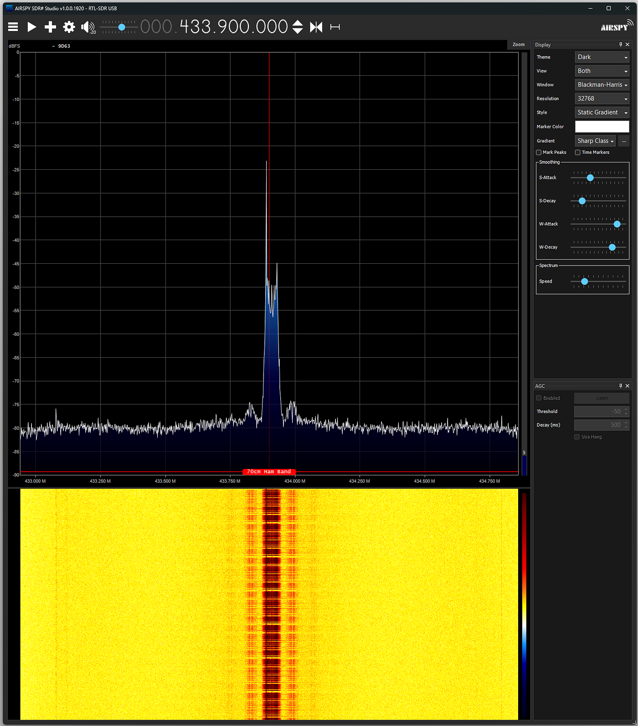

Here is what 250,000 baud looks like:

Press enter or click to view image in full size

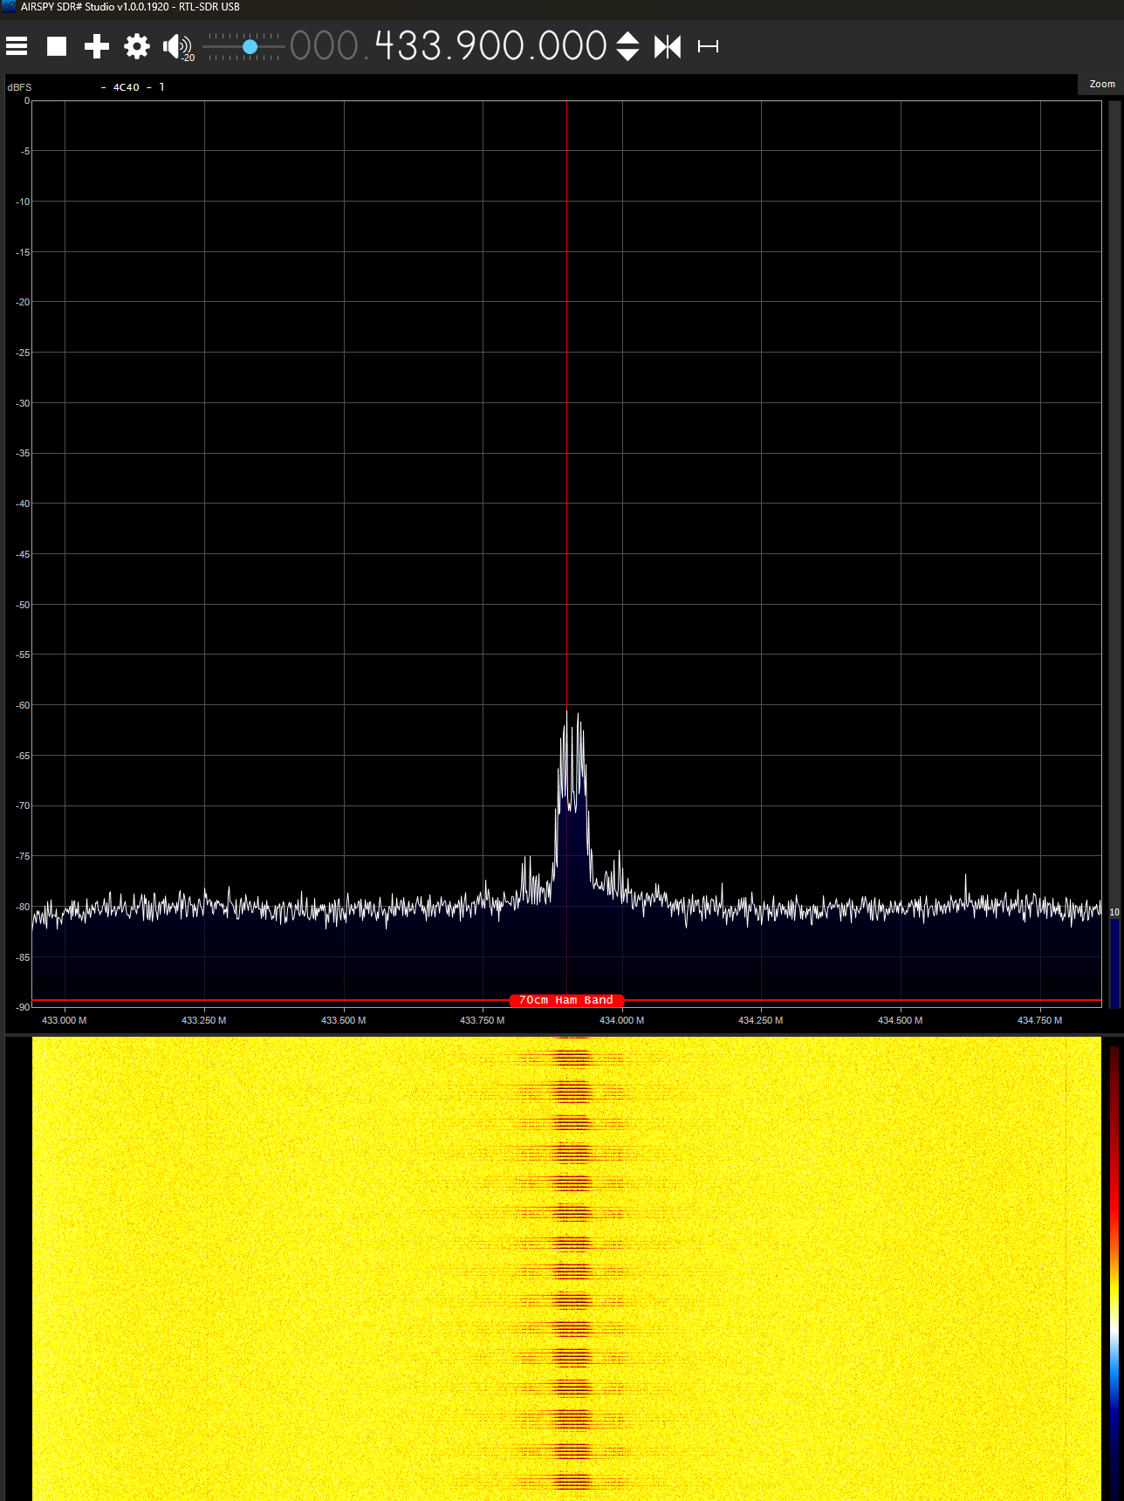

We get much better range at the lower baud rate, due to the tighter filtering possible, which increases the signal-to-noise ratio a lot.

Gaussian Frequency Shift Keying uses two frequencies and softens the transition between them using a Gaussian filter. This uses less bandwidth than without the filtering and allows higher data rates.

The radio can also handle 4-FSK, where four tones are used, doubling the data rate in the same bandwidth. Here is what that looks like:

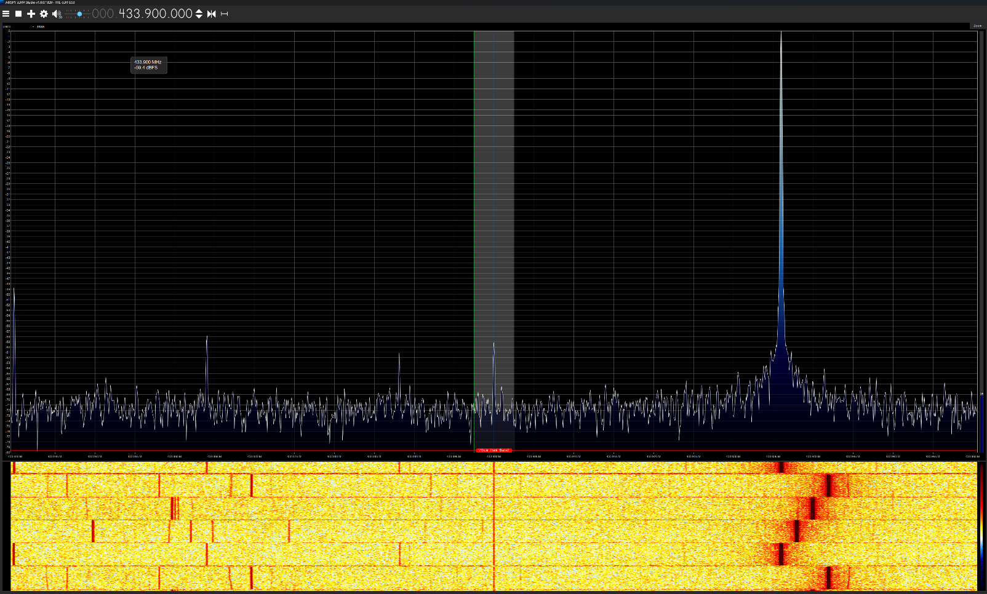

All of this capability comes for $1.27, including the antenna. The ESP32-C3 Super Mini adds another $5.79. You can explore sophisticated radio networking for about $7 per node.

Here is the whoami.py module:

class WhoAmI:  
 def __init__(self):  
 self.me = {}  
 try:  
 with open("whoami.cfg","rb") as f:  
 line = f.read(1024)  
 from json import loads  
 self.me = loads(line)  
 except OSError as e:  
 print("Error reading whoami.cfg:", e )  
  
 def name(self):  
 if "name" in self.me:  
 return self.me["name"]  
 return "Unknown"  
  
 def baud(self):  
 if "baud" in self.me:  
 return self.me["baud"]  
 return 38.4  
  
 def fec(self):  
 if "fec" in self.me:  
 return self.me["fec"]  
 return True  
  
 def gdo0(self):  
 if "gdo0" in self.me:  
 return self.me["gdo0"]  
 return None  
  
 def gdo2(self):  
 if "gdo2" in self.me:  
 return self.me["gdo2"]  
 return None  
  
 def csn(self):  
 if "csn" in self.me:  
 return self.me["csn"]  
 return None  
  
 def sck(self):  
 if "sck" in self.me:  
 return self.me["sck"]  
 return None  
  
 def mosi(self):  
 if "mosi" in self.me:  
 return self.me["mosi"]  
 return None  
  
 def miso(self):  
 if "miso" in self.me:  
 return self.me["miso"]  
 return None  
  
 def ip(self):  
 if "ip" in self.me:  
 return self.me["ip"]  
 return None  
  
 def mask(self):  
 if "mask" in self.me:  
 return self.me["mask"]  
 return None  
  
 def gateway(self):  
 if "gateway" in self.me:  
 return self.me["gateway"]  
 return None  
  
 def dns(self):  
 if "dns" in self.me:  
 return self.me["dns"]  
 return None  
  
 def neo_pin(self):  
 if "neo_pin" in self.me:  
 return self.me["neo_pin"]  
 return None  
  
 def neo_how_many(self):  
 if "neo_how_many" in self.me:  
 return self.me["neo_how_many"]  
 return None  
  
 def set_ip(self, sta):  
 if "ip" in self.me:  
 sta.ifconfig((self.me["ip"], self.me["mask"], self.me["gateway"], self.me["dns"]))

Here is alice.cfg (copy it to whoami.cfg on the transmitter):

{"name":"Alice","neo_pin":21,"neo_how_many":1, "gdo0":10, "gdo2":9, "csn":15, "sck":12, "mosi":11, "miso":13, "baud":38.4, "fec":1}

Here is bob.cfg (copied to whoami.cfg on the receiver):

{"name":"Bob","neo_pin":21,"neo_how_many":1, "gdo0":4, "gdo2":1, "csn":3, "sck":8, "mosi":10, "miso":9, "baud":38.4, "fec":1}

On Windows, I use this script to copy the files:

set comport=%1  
if "%comport%" == "com4" copy alice.cfg whoami.cfg  
if "%comport%" == "com5" copy bob.cfg whoami.cfg  
  
mpremote connect %comport% rm main.py  
mpremote connect %comport% rm whoamy.py  
mpremote connect %comport% rm whoamy.cfg  
  
mpremote connect %comport% cp whoami.py :whoami.py  
mpremote connect %comport% cp whoami.cfg :whoami.cfg  
mpremote connect %comport% cp main.py :main.py

You don’t actually need the lines that remove the old files. They are there because, during debugging, sometimes the processor would start up before the next file could be sent, and removing main.py stopped that.